|  |  |
| --- | --- |
| **THE NATURE OF RESISTANCE** | http://coachdawnwrites.com/wp-content/uploads/2014/01/resistance.jpg |

**Introduction**

This lab is a series of guided activities that explore the *microscopic* and *macroscopic* factors that influence the electrical resistance of conducting materials. You will examine how temperature and voltage affect electron motion in a metal, learn about defects in metals and how they impact resistivity, and investigate how geometry influences the resistance of Play-Doh™ (Play-Doh™ is an ionic conductor). All activities explore the important equation for resistance, R:



where:

***ρ*** is the resistivity, which is a material property of the resistor (microscopic property)

***l*** is the length of the resistor (macroscopic property)

***A*** is the cross-sectional area of the resistor (macroscopic property)

**Prelab Questions:**

1. A simple circuit in your house contains wires that connect a switch to a light. Describe what you think electrons in the wires do when you flip the switch and turn on a light.
2. Give your best estimate of how fast the electrons move through the wire when the light is turned on.
3. The fire department says you should never run big appliances off extension cords. Why do you think they give this advice?
4. Why do you think power lines have a large diameter and why does the tungsten filament in a light bulb have a very small diameter?

**Part I – The Soccer Ball Activity**

Follow the instructions for the **Soccer Ball Activity** and answer the following the questions.

1. Draw an arrow on both pictures from the initial to the final ball position. What is the difference between the two vectors?
2. Assuming no barriers (i.e. trees and rocks), explain what geographic feature could have caused the soccer ball to take such a different path.
3. In this exercise, the soccer ball is used to model the behavior of an electron in a metal. What do you think the geographic feature you identified represents in an actual electrical system?

**Part II (A)– Electron Motion in a Metal – Thermal Motion**

**Materials:**

* Thermal Motion activity sheet
* Two color pencils
* One die
* Small ruler

Follow the instructions on the **Thermal Motion** activity sheet and then answer the following questions:

1. Length of your net vector (cm): ____________
2. Class average for the net vector length (in cm): ____________

|  |  |
| --- | --- |
| 1. On the chart, draw a vector (an arrow) to show the resulting direction from your starting point to the ending point (use a colored pencil).   Compare with at least three other groups. Using a different color pencil, draw the vectors produced in the others’ experiments on the same grid. | \\cosfs.science.purdue.edu\UserData\dsederbe\Desktop\SE Labs in Word\resistance vector grid.jpg |

1. Based on comparing the overall results from the class, what effect does the continued rolling of the die have on the resulting movement of the electron in your model?
2. Making any kind of matter move requires energy. Where did the electrons get the energy in this activity?
3. What do you think happens to the atoms in the metal as the temperature increases?
4. Under what conditions that would atoms in a metal have the least possible motion (least thermal energy)?
5. What effect you think this might have on the ability of a metal to conduct electric current?

**Part II (B) – Thermal Motion + Voltage**

In the first dice activity you learned that electrons at room temperature are constantly moving, even if their net motion is very small. Now let’s see what happens to the net motion of electrons in a metal at room temperature *when a voltage is applied*.

**Materials:**

* Thermal Motion + Voltage activity sheet
* Two color pencils
* One die
* Small ruler

Follow the instructions on the **Thermal Motion + Voltage** activity sheet and then answer the following:

1. Length of your net vector (in cm): ____________.
2. Class average for the net vector length (in cm): ____________.

|  |  |
| --- | --- |
| 1. On the chart to the right, indicate with a vector the general direction of the movement of your electron from starting point to end point (use a colored pencil).   Use a different color pencil to draw the vectors produced by other groups in your class on the same grid. | \\cosfs.science.purdue.edu\UserData\dsederbe\Desktop\SE Labs in Word\resistance vector grid.jpg |

1. Explain why these results are different from those for the thermal motion activity.
2. The arrow in this activity indicates a voltage applied to the conducting material. What rule changed between this activity and the *Thermal Motion* modeled the presence of voltage?

**Comparing Parts A and B (Thermal Motion and Voltage)**

Before we move on, let’s think about what we just did. In Part A, you used a model to represent the motion of an electron in a metal conductor, solely as a function of temperature (thermal energy). In part B, you used the same model, but added a voltage applied from the outside.

1. How would you put into words the relationship between temperature and drift velocity (the rate at which electrons move about in a metal)?
2. Explain the effect you think temperature might have on the electrical resistance of a conducting material.

Using one variable for temperature (say, T), and another variable for resistance (for now you can use R), try to make up an equation to express the relationship mathematically.

1. Based upon this dice activity, describe how current carrying electrons *really* move in a metal.
2. Under typical operating voltages, electrons *drift* at a velocity approximately 10-3 cm/s (1 billion times slower than the electron speed between collisions!) How long will it take an electron to traverse a 10 cm long wire if its drift velocity is 10-3 cm/s? Show your calculation and express your answer in hours. Is this what you expected?
3. If the soccer ball represents an electron and the hill represents the voltage, how would reducing the voltage affect the electron’s drift velocity?

|  |
| --- |
| People often assume that electrons travel in straight lines down a wire in a closed circuit like water flows through a pipe, or that electrons travel through a conductor at the speed of light. The truth is: an electron moves with a speed approximately 106 cm/s **between collisions** (1/100 of the speed of light). But this motion isn’t producing current, since on average the electrons aren’t going anywhere, as you saw in the first dice activity! What do you think those electrons contribute to the system, if they do not carry current? |

**Part III – Thermal Motion + Voltage + Grain Boundaries (How defects affect resistivity, *ρ*)**

(This activity is used by permission of Materials Science and Technology Teacher's Workshop, Department of Materials Science and Engineering University of Illinois Urbana-Champaign)

**Part a: Material defects**

The BBs in this activity represent atoms in a metal. Atoms occupy specific, ordered positions in crystalline metals. In a perfect crystal (as represented by this 2D BB model) each atom (BB) is surrounded by 6 atoms (BBs). (See Figure 1, below.)

Crystalline metals commonly exhibit multiple types of defects. We will explore two of them with the BBs. A vacancy (Figure 2) is a missing atom. A grain boundary is the disordered region between two crystalline regions of different orientation (Figure 3).

**Materials:**

* Copper BBs in a clear CD case

**Directions:**

1. Holding the case of BBs flat and just slightly at an angle to the horizontal, try to make a perfect crystal with the BBs in the CD case.
2. Examine your attempt at the perfect crystal to see if you have these defects. If not, see if you can create vacancies (Figure 2) and grain boundaries (Figure 3)

|  |  |  |
| --- | --- | --- |
| Perfect Crystal |  |  |
| Figure 1 | Figure 2 | Figure 3 |

1. What did you have to do to come as close as possible to making a perfect crystal?
2. What processes did you simulate in your manipulation of the BBs?
3. Based on your experience in this activity, what do you think is the importance of materials science researchers attempting to find ways of growing perfect crystals?

|  |  |
| --- | --- |
| 1. In the box to the right, based upon your observations of the BBs in your CD case, draw a vacancy. Represent the atoms as circles. |  |

|  |  |
| --- | --- |
| 1. In this box, draw two area of different grains and the grain boundary between them from your BB model. Use circles to represent atoms and carefully show the arrangement of atoms at the grain boundary and within the grains. |  |

**Part b: Thermal Motion + Voltage + Grain boundaries:**

Now we explore the effect of defects on electron drift. This is seen at really low

temperatures (where the thermal effect is small) or for very small grain sized materials

(nanomaterials).

**Materials:**

* Thermal Motion + Voltage + Grain Boundaries activity sheet
* Two color pencils
* One die
* Small ruler

Answer the following questions after completing the **Thermal Motion + Voltage+ Grain Boundaries**activity:

1. What is the effect of grain boundaries on electron drift in a metal?
2. Study the two pictures of grain structure in a metal below.

A B

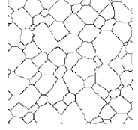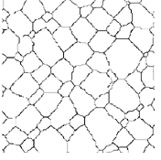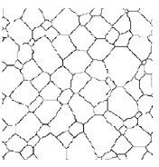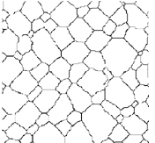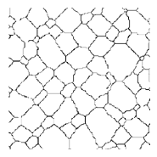

If both images were taken at the **same magnification**, which one would have higher resistivity at very low temperatures, where the thermal contribution to resistivity is small? Why?

**Part IV – Making a Play-Doh™ Resistor: (How *l* and *A* Affect *R*)**

Now you have learned something about what happens inside a metal and explored factors that affect its resistivity ***ρ***, you will now examine how the geometry of a resistor affects its resistance using Play-Doh™.

Play-Doh™ doesn’t conduct electricity via mobile electrons, as in a metal, but rather by mobile ions from ionic salts used in making the material ionic conductor. These salts make good conductors of electric current.

Note that you will be using Ohm’s Law to calculate the resistance of the Play-Doh™ resistor, rather than measuring it directly. The is because the resistance will be too large to be measured with the multimeter.

Read through the directions complete before you begin.

**Materials:**

* Play-Doh™
* 2 pieces of metal rod
* Multimeter
* 9V battery
* 3 connecting wires with alligator clips
* Small ruler
* Plastic knife
* Sandpaper
* Wooden support blocks
* Graph paper, EXCEL or equivalent

**Important note:**

|  |  |
| --- | --- |
| Exposure to air and current dries out the Play-Doh™ , which will adversely affect your measurements. Leave your Play-Doh™ in the container as long as possible to keep it moist.  Do not leave the circuit connected throughout the experiment, because the salts in the Play-Doh™ will corrode the probes. Connect the circuit when you are ready to take a measurements, and disconnect the circuit between measurements.  The diagram at right shows the connection pattern to complete the circuit for your measurements. |  |

**Part a: Explore how the resistor length affects the resistance**

1. Using the multimeter as a voltmeter, measure the battery voltage. Record value. Set up the multimeter as a current meter. **Set the multimeter to the 200 mA scale**.
2. Roll a shape of Play-Doh™ that is about 12-14 cm long and about an inch in diameter. Measure the exact diameter of the resistor using the caliper. Record your data in the table on the next page.
3. Calculate the cross-sectional area and add this value to the data table.
4. Sand the ends of the metal rods to ensure good electrical contact (to remove oxidation or old Play-Doh™).

|  |  |
| --- | --- |
| 1. Push one rod cross-wise across the Play-Doh™ resistor, about 1 cm from the end, perpendicular to the axis of the resistor. This will be the **stationary probe**, and will remain in place. 2. You will be inserting the **mobile probe** at 1 cm intervals across the length of the resistor and measuring the corresponding current. 3. You will record the **distance** between the probes and the measure the corresponding **current** using the multimeter. |  |

1. **Do not connect the multimeter until you have mobile probe in place and are ready to make a measurement.** Insert the mobile probe, connect the multimeter, record the current and disconnect the multimeter. Be quick, as the values will rapidly begin to drift.
2. Calculate the resistance using Ohm’s Law, and add the resistance values to the tables.
$$\text{R (resistance)} \text{=}\frac{\text{voltage (V)}}{\text{current (I)}}$$

3. Plot the resistance vs. length on a graph.

|  |  |  |
| --- | --- | --- |
| Battery voltage:  ________ V | Diameter: _____________ cm  Cross-sectional area: ______________ cm2 | |
| Resistor length  (cm) | Current  (mA) | Resistance  (Ω) |
| 1 |  |  |
| 2 |  |  |
| 3 |  |  |
| 4 |  |  |
| 5 |  |  |
| 6 |  |  |
| 7 |  |  |
| 8 |  |  |
| 9 |  |  |
| 10 |  |  |

**Part b: Explore how the cross-sectional area affects the resistance**

1. Measure the battery voltage again and record the value in the table below. Now set up the multimeter as a current meter.
2. Using the entire can of Play-Doh™, roll out a Play-Doh™ cylinder that is 10 cm long. Take care to keep the cross-sectional area as uniform as possible.
3. Measure the diameter of the Play-Doh™ resistor and record it in the table. Use the same circuit model you used previously, and you’re ready to collect your data.
4. Push the metal rods into your resistor about 1 cm from each end, connect the circuit and record the current. **Remember to disconnect the circuit immediately** **between measurements**.
5. Cut your cylinder in half and put the extra Play-Doh™ back in the container to keep it moist.
6. Roll out the remaining Play-Doh™ so that it is again uniform in cross-section and10 cm long.
7. Measure the diameter and record the data in the table.
8. Measure the current, disconnect the circuit immediately, and record the data. Repeat this process one more time, so you now are using about ¼ of the original amount of Play-Doh™.
9. Again, using Ohm’s law, calculate the values for the resistance and fill in the table below.

|  |  |  |  |
| --- | --- | --- | --- |
| Effect of Cross-sectional Area on Resistance  (Resistor length = ~10 cm) | | | |
| Battery voltage: __________ (v) | | | |
| Resistor diameter (cm) | Cross sectional area (cm2) | Current  (mA) | Resistance  (Ω) |
|  |  |  |  |
|  |  |  |  |
|  |  |  |  |

**Questions**

Answer related questions using your knowledge of Ohm’s Law and the equation,



where:

***ρ*** is the resistivity, which is a material property of the resistor

***l*** is the length of the resistor

***A*** is the cross-sectional area of the resistor

1. Draw a line showing the general relationship between the following properties.

|  |  |  |  |
| --- | --- | --- | --- |
| \\cosfs.science.purdue.edu\UserData\dsederbe\Desktop\SE Labs in Word\Nature of Resistance\N Resistance Current-Length.png | \\cosfs.science.purdue.edu\UserData\dsederbe\Desktop\SE Labs in Word\Nature of Resistance\N Resistance Current-Diameter.png | \\cosfs.science.purdue.edu\UserData\dsederbe\Desktop\SE Labs in Word\Nature of Resistance\N Resistance Voltage-Resistance.png | \\cosfs.science.purdue.edu\UserData\dsederbe\Desktop\SE Labs in Word\Nature of Resistance\N Resistance Resistivity-Length.png |

1. What is the resistivity of your Play-Doh™? Use your plot of resistance vs. length to get your answer. Show your work.
2. Would you expect the resistivity of Play-Doh™ to increase or decrease with moisture content? Explain your answer.

**Post-lab Analysis**

1. You know that energy can’t be created or destroyed; it can only be transformed. Describe the energy transformation that you think occurs in a resistor.
2. The current density, j, is the current/unit area (j = i/A). Using the concepts you’ve learned in this lab, explain why for a given current, a thin wire would get hotter than the fat wire.
3. The graph below represents actual information on the resistivity of copper. Using what you learned in this lab, study the graph and answer the following questions:

|  |  |
| --- | --- |
| Why is the resistivity higher at point C than at point B? | \\cosfs.science.purdue.edu\UserData\dsederbe\Desktop\SE Labs in Word\Nature of Resistance\N Resistance Residual p.png |

Why does region A not extrapolate to zero?

1. Let’s say you and a friend are watching a bad science video on YouTube that models electricity as ping-pong balls flowing through a tube. How would you explain to your friend what is wrong with this model?
2. AWG = American Wire Gauge. Normal household circuits are constructed using mostly AWG 12 and AWG 14 wire. If 12-gauge wire as a diameter of 2.053-mm and 14-gauge wire has a diameter of 1.628-mm, why would you prefer to use 12-gauge wire to wire your house?

**Part I: The Soccer Ball Activity**

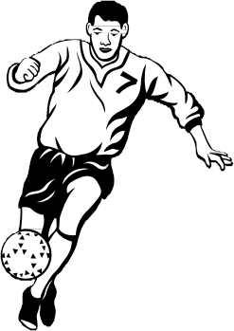Imagine you are in an open field and are given a soccer ball and the set of instructions below. Although you try your best to kick the ball according to the instructions, the results of your kicks are very different. Hints: 1) you kick the ball squarely without any spin when you kick and 2) you are not on a soccer field.

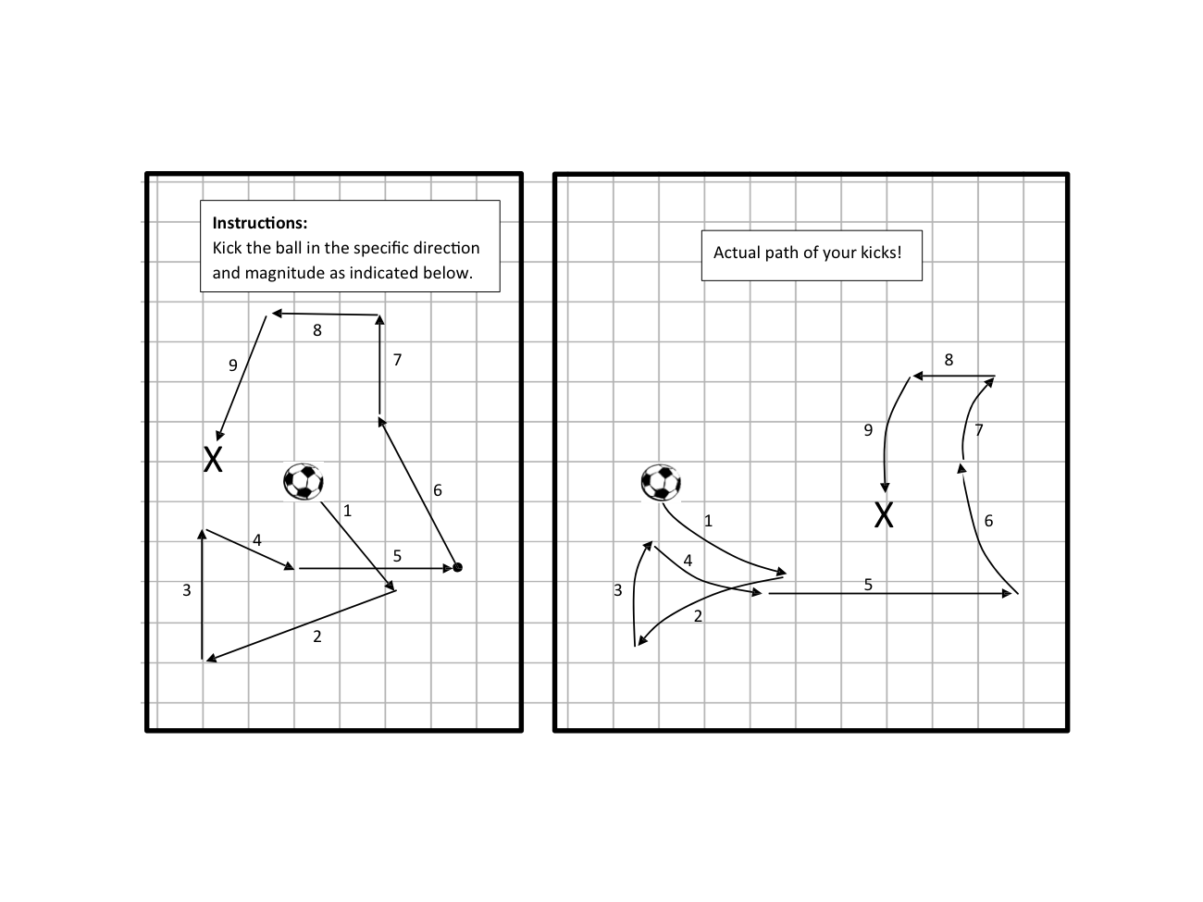

**Part II: Thermal Motion:**

**(How an electron moves in a metal at temperatures above absolute zero)**

**The rectangle below represents a piece of a metal wire. The black dot near the center of the wire represents an electron, whose thermal motion you will follow. The circles numbered 1 - 6 represent the atom in the wire.**

**Rules of the activity:**

1. Begin at the black electron dot drawn near the center of the wire.

2. Roll the die. The number rolled indicates the next atom the electron will move toward.

3. Here are the rules for moving to the next location:

(1) You must **choose the numbered circle closest to the current electron position**.

(2) If you roll the number of the atom you are currently on, then **move your electron to the closest same number**.

(3) If you have equidistant numbers, then **always go back towards the starting point.**

4. Draw a dot in the numbered circle to indicate the new position of the electron and an arrow pointing from the present 1 2

electron position to the new location based on the number rolled.

5. Continue this process for 15 rolls of the die.

6. Draw a fat arrow from the original electron position to the final electron position. This arrow is a vector that represents the net motion of the electron.

7. Measure the length of the vector (in cm) and note its direction. Record your result on the student sheet.

8. Answer questions on your answer sheet.

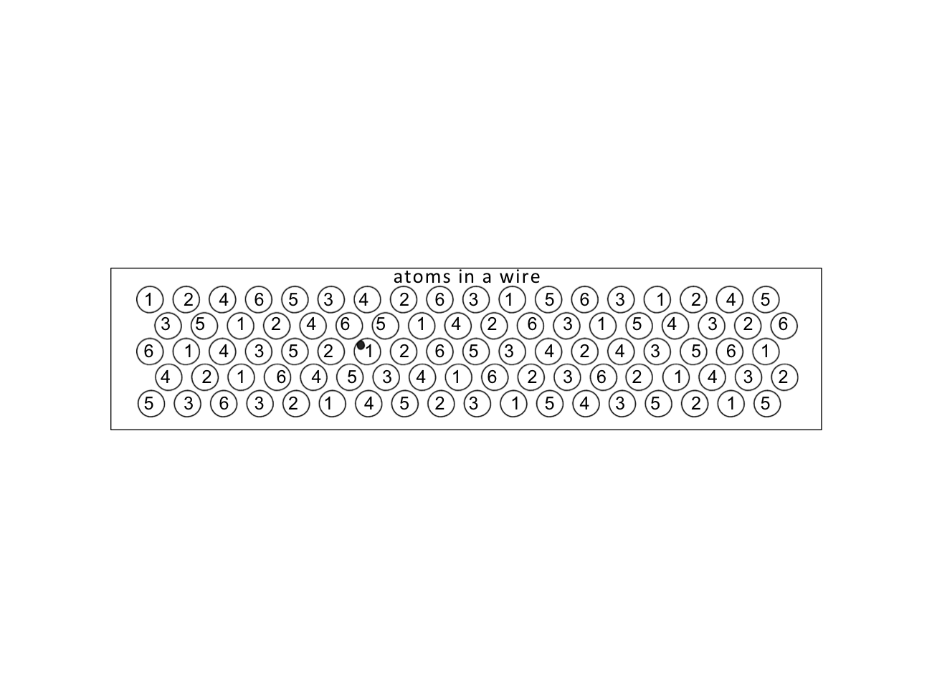

**Part II: Thermal Motion + Voltage:**

**(How an electron *drifts* in a metal under an applied voltage at temps above absolute zero)**

**Rules of the activity:**

1. Begin again at the black electron dot drawn near the center of the wire.

2. Roll the die. The number rolled indicates the next atom the electron will move toward.

3. Here are the rules for moving to the next location (read carefully – rule 3 changes when adding a voltage!): (1) You must choose the numbered circle **closest to the current electron position**.

(2) If you roll the number of the atom you are currently on, then move your electron to **the closest same number**. (3) If two numbers are equidistant from where you are, then **always move towards the (+) electrode***.*

4. Draw a dot in the numbered circle to indicate the new position of the electron and an arrow from the present electron

position to the new location based on the number rolled. 1 2

5. Continue this process until you have reached the right end of the wire or have rolled the dice 15 times.

6. Draw a fat arrow from the initial position to the final position of the electron. This arrow is the vector that represents the net motion of the electron.

7. Measure the length of the vector (in cm) and note its direction (right or left) and record your result on the student sheet.

8. Compare the length of this fat arrow to the fat arrow from the previous activity.

9. Answer questions on your answer sheet.

*Wire connected in a circuit with an applied voltage indicated by + and – signs:*

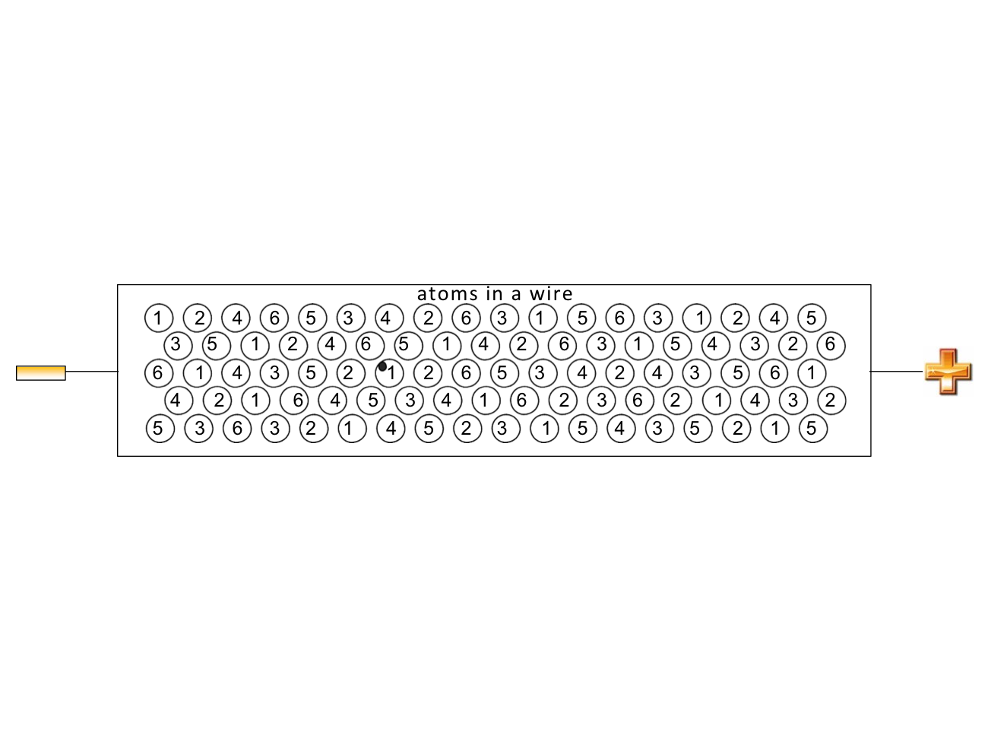

**Part III: Thermal Motion + Voltage + Grain boundaries:**

**(Effect of defects on an electron drifting at temperatures above absolute zero)**

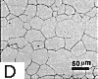Grain boundaries are regions where differently oriented crystals in a metal meet (see the figure at right).. They regions in between them, called grains. Grain boundaries are defects in metal structure since the arrangement of atoms is more disordered there than within a well ordered crystal lattice.

**Rules of the activity:**

1. Begin at the black electron dot.

2. Roll the die. The number rolled indicates the next atom the electron will move toward.

3. Here are the rules for moving to the next location (read carefully – there are additional rules for defects!): (1) Use the rules for the voltage activity.

(2) In addition, you can only **move across a grain boundary if you are on one of the adjacent atoms (indicated with a *)**. (3) When you are at an atom along the grain boundary, **you must roll the number of the atoms just on the other side of the boundary to cross it**. If you do not roll this number, the electron must scatter back to the closest number you rolled. (4) Once you have moved passed a grain boundary, *you can not cross back*.

4. Draw a dot in the numbered circle to indicate the new position of the electron and an arrow from the

present electron position to the new location based on the number rolled.

5. Continue this process until you have reached the end of the wire or rolled the dice 15 times.

6. Draw a fat arrow from the original to the final electron position. This vector represents the net motion of the electron.

7. Answer questions on your answer sheet.

